


BRYAN-EVANS RETIRED EDUCATORS ASSOCIATION
Volume 2 Issue 1 August 2010
GREA-BEREA UNITED

“BUILDING A GIGANTIC ORGANIZATION” 2010-2011
Hammer Down Membership …. Extend Visibility…Tighten Up Retention

A Message from the President:
As I pondered what I needed to write, I decided I had two choices. I could copy Faye Hodges’ great message from last year or find a ghostwriter. Neither of those seemed like a good plan, so I had no choice but to write it myself and expose my poor writing skills.

I want to welcome you all back from your summer break. I especially want to congratulate and welcome our new retirees. For me the first year of retirement was more than a little unsettling. I found BEREA meetings and fellowship helped me to settle into this new phase of my life. I hope all of you new retirees will embrace the family of BEREA as you start your new life.

I met with the planning committee July 27th. With their help, we have planned interesting and informative programs for this year. The biggest challenge so far has been updating the committees. If you would like to participate in any of the committees, please let me know and I will gladly add your name.

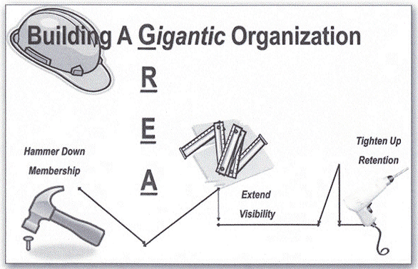
The new State President’s, Doris Wilson, Motto for GREA this year is “Building A Gigantic Organization.” One of her projects is HOPE (Helping Other People Endure). She is asking the local units to collect socks and T-shirts (all sizes) for hospitals across Georgia. We will donate our collection to Georgia Regional Hospital.

I am counting on your support and advice this year. Remember you told me you would help and I am holding you to that promise.
I am looking forward to seeing you at our first meeting in September. Call or bring a new or “old” retiree to our first meeting.

Please feel free to contact me by phone or email anytime with any thoughts, ideas, or concerns. My email address is
lamiller_2@msn.com .
Anne

September Meeting Program:
Our first meeting is on Tuesday,

September 14, at the Pembroke United
Methodist Church.
The program will be “Fall Gardens”
by Don Gardner- Bryan County
Extension Agent.

Meeting Date/Programs:

9-14-10 Pembroke - UMC –
Don Gardner

10-12-10 Claxton - Mrs. Roger’s
Rest. - Jack Kingston*

11-9-10 Richmond Hill- Southern
Image Rest.- Doris Wilson

12-14-10 Pembroke- BCMS
BCMS Chorus: “Christmas Program”

2-8-11 Claxton- Mrs. Rogers' Rest.
Hospice

    - Richmond Hill- Southern Image
Rest.- Lottie Scott –62+*

    - Pembroke – UMC, Program
about Truett Cathy,

May 10-12, 2011 – GREA State
Convention in Savannah
* not confirmed
General Meeting Agenda
2nd Tuesday of each Month

10:30 - Registration and Fellowship
10:45 - Business Meeting Begins
11:00 - Program/ Guest Speaker

12:00 - Lunch
1:00 - Adjourn

New Retirees:
These are the contact numbers if you need more information about our meetings.
Claxton: Jerry Swain 739-2686
Pembroke: Nancy Page 858-2800
Richmond Hill: Sallie Brewer 665-1018

BREA Officers 2010-2011

Anne Miller – President 858-2362
David Green – President-Elect 739-1771
Delores Fields – Secretary 234-4975
Anne Sanders – Treasurer 653-2263
Mamie Moore – Parliamentarian 236-6479
Membership in
GREA/BEREA

If you have not already sent your membership applications to the state office you may bring it to the meeting and give it to Anne Sanders, Treasurer of BEREA.
Local Membership dues are
$10.00
State GREA dues are $24.00
State Life dues are $360.00
We encourage you to select the ADD (automatic deduction) payment method which is only $2.00 per month deducted from your TRS check for the GREA dues. Membership in the state GREA is really important when it comes to legislation, especially when the state government is constantly trying to “play” with our retirement funds.

Using Technology
I want to continue using email as a way to contact you and give you the latest news about GREA/BEREA. At the area meeting in Savannah, it was suggested that we might want to use Calling Post. This site will call the members of an organization and remind them of meetings and other important information. I hope to have this in operation by the first meeting, so you might get an automated telephone call from BEREA.

Brunch
According to tradition, the first meeting is a brunch given by members of the BEREA at the Pembroke United Methodist Church Social Hall. Nancy Page has so graciously offered to organize this brunch. If you would like to help, please contact Nancy at 858-2800. We will eat before the meeting, so you can skip breakfast and come hungry. The brunch will start around 10:45 and our meeting will follow the brunch.

I want to thank Delores Fields, Dorothy Geter, Gloria Carter, Nell Purcell, Nancy Page, and Claudia Christiansen for attending the GREA Area V and VI meeting in Savannah on August 17th. I really appreciated their support and advice.

Please remember that we need socks and T-shirts for the hospital.
Bring what you can to support our president, Doris Wilson, and her project.
Mr. Hite will be picking them up sometime in October. Thanks, Anne

What: BRYAN-EVAN REA MEETING
Where: Pembroke United Methodist Church Social Hall
When: September 14, 2010
Time: 10:30 AM




BEREA News
Anne Miller, President
1135 Blue Gill Rd.
Ellabell, GA 31308

