
BY THE GOVERNOR OF THE STATE OF GEORGIA
A PROCLAMATION RETIRED EDUCATORS DAY
WHEREAS: More than 86,000 retired educators have devoted their time,
energies and talents to public education, providing the educational development of millions of outstanding Georgia citizens; and
WHEREAS: Retired educators touched and influenced the lives of generations
of young people and motivated and inspired them to use their innate talents and abilities to the fullest and to become responsible and contributing citizens; and
WHEREAS: Retired educators possess valuable knowledge and use their
lifetime experiences and skills to enrich the educational process in a variety of settings. They often continue to be a major source of insight and direction for our state and our nation. Many continue to serve in religious, civic and political organizations; and
WHEREAS: For over 52 years, the Georgia Retired Educators Association has
dedicated its efforts to improving the welfare to retired educators and has provided opportunities for them to become involved in community activities; and
WHEREAS: All citizens of Georgia owe a debt of gratitude and appreciation
to retired educators for their dedicated service to our state and nation; now
THEREFORE: I, SONNY PERDUE, Governor of the State of Georgia, do hereby
proclaim November 7, 2010, as RETIRED EDUCATORS DAY in Georgia and urge our citizens to recognize the lasting contributions of our state's retired educators.
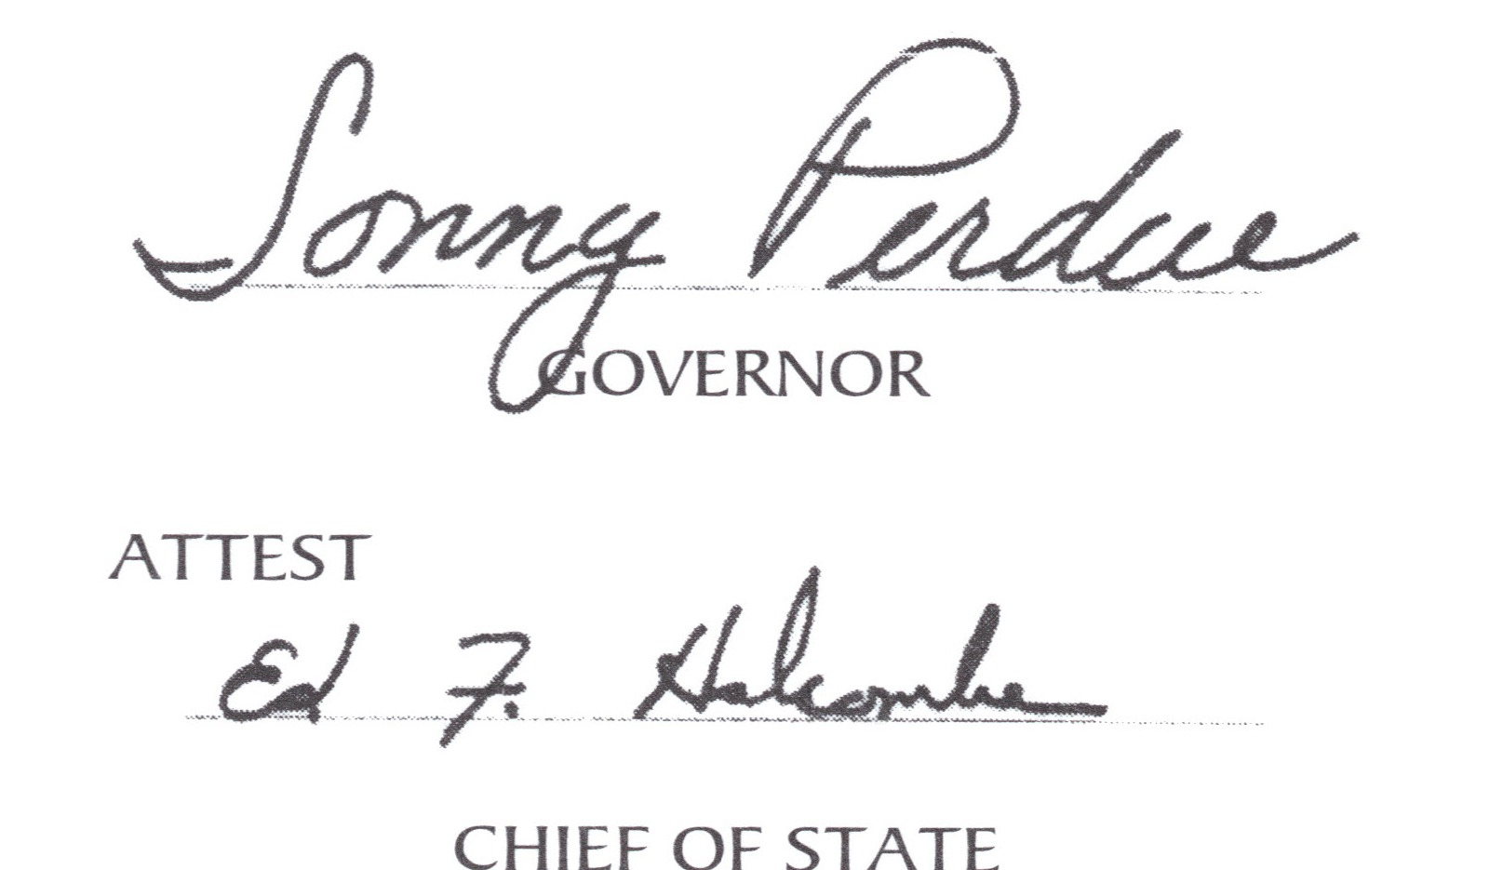
In witness thereof, I have hereunto set my hand and caused the Seal of the Executive Department to be affixed this 9th day of September in the year of our Lord two thousand ten.

BY THE GOVERNOR OF THE STATE OF GEORGIA
A PROCLAMATION RETIRED EDUCATORS DAY
WHEREAS: More than 86,000 retired educators have devoted their time,
energies and talents to public education, providing the educational development of millions of outstanding Georgia citizens; and
WHEREAS: Retired educators touched and influenced the lives of generations
of young people and motivated and inspired them to use their innate talents and abilities to the fullest and to become responsible and contributing citizens; and
WHEREAS: Retired educators possess valuable knowledge and use their
lifetime experiences and skills to enrich the educational process in a variety of settings. They often continue to be a major source of insight and direction for our state and our nation. Many continue to serve in religious, civic and political organizations; and
WHEREAS: For over 52 years, the Georgia Retired Educators Association has
dedicated its efforts to improving the welfare to retired educators and has provided opportunities for them to become involved in community activities; and
WHEREAS: All citizens of Georgia owe a debt of gratitude and appreciation
to retired educators for their dedicated service to our state and nation; now
THEREFORE: I, SONNY PERDUE, Governor of the State of Georgia, do hereby
proclaim November 7, 2010, as RETIRED EDUCATORS DAY in Georgia and urge our citizens to recognize the lasting contributions of our state's retired educators.
In witness thereof, I have hereunto set my hand and caused the Seal of the Executive Department to be affixed this 9th day of September in the year of our Lord two thousand ten.



GEORGIA RETIRED
EDUCATORS ASSOCIATION
Fellowship... Support. ..Service
Founded in 1958, Georgia Retired Educators Association is an organization that enhances retirement and fulfills the individual. What does GREA mean to retired educators?
- "I need someone to look after my retirement income, protect it and keep it strong for years to come - it's the right thing to do." -John Yates, Dahlonega
- "GREA offers opportunities for fellowship, support and continued service to mankind." -Burney Lester, Macon
- "GREA brings increased security, quality fellowship, valuable information and indescribable pizzazz into my life." -Evelyn Collins, Baxley
- "Family is important to me, and I want to be a part of seeing that every member of this (my) family is protected, loved, and appreciated." -Charles Cope, Conyers

GREA is the only organization that concentrates exclusively on the welfare of Georgia Retired Educators.

GREA invites your inquiries to:
Park Place 1
322 Oak Street
Gainesville, GA 30501-3580
770-287-7721 or 800-637-2883

GEORGIA RETIRED
EDUCATORS ASSOCIATION
Fellowship... Support. ..Service
Founded in 1958, Georgia Retired Educators Association is an organization that enhances retirement and fulfills the individual. What does GREA mean to retired educators?
- "I need someone to look after my retirement income, protect it and keep it strong for years to come - it's the right thing to do." -John Yates, Dahlonega
- "GREA offers opportunities for fellowship, support and continued service to mankind." -Burney Lester, Macon
- "GREA brings increased security, quality fellowship, valuable information and indescribable pizzazz into my life." -Evelyn Collins, Baxley
- "Family is important to me, and I want to be a part of seeing that every member of this (my) family is protected, loved, and appreciated." -Charles Cope, Conyers

GREA is the only organization that concentrates exclusively on the welfare of Georgia Retired Educators.

GREA invites your inquiries to:
Park Place 1
322 Oak Street
Gainesville, GA 30501-3580
770-287-7721 • 800-637-2883

