Name___________________________ Date_______(3-07)

Counting by 2: (40)
222 | 224

- HD Q Q DD PP = $____.____
- $ Q Q DNNN P = $___.____
- $ DDDNNN N P= $___.____
- FIRST write the number ______
- THIRD write the number _______
- Twice as much as 6 is ______
- Twice as much as 8 is _____

- tally 18 _________________
- one hundred and thirty ________
- 7+7 12-8 < >
- 15-9 14 – 7
- ______
- ______
- ______

43  +57 | 54  +27 | 47  +73 | 35  +15 | 69  -27 | 41  -36 | 52  -25 | 45  -17
34  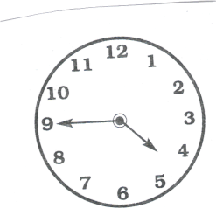  -17 | 50  -29 | 33  -25 | 48  +4 | 41  +8 | 25  -8 | 54  -7 | 21  -7
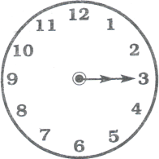
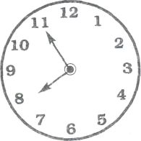
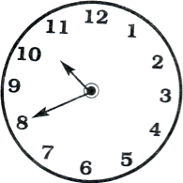
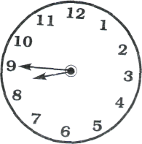
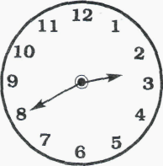
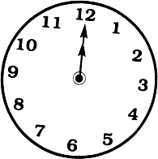

____:____ ____:____ ____:____ ____:____ ____:____ ____:____ ____:____
Name_____________________Date_____________ 3-07 (33)
Counting by 2:
222 | 224

___ in. l_____________________l

___ in. ______________l

___ in. l___________________________________________l

____ in. l__________________________________

8 | 10 | 12

- $ QDNN P= $____.____
- $ QDNP = $_____.____
- Q Q Q D D N P = _______¢
- has ______flat surfaces
__  42  +57 | __  72  +27 | __  38  +18 | __  28  +74 | __  62  -34 | __  81  -38 | __  53  -24 | __  94  -58
__  25  +2 | __  38  +9 | 52  +4 | __  85  -47 | __  47  -28 | __  72  -34 | 17  23  +32 | 22  13  +17
- has ______flat surfaces
6. (4 + 8) - 5 = _______
7. two hundred and thirty-three _____________
8. ______________

- ______
- ______

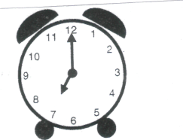
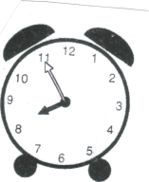
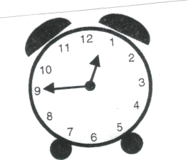
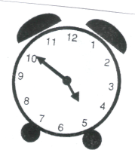
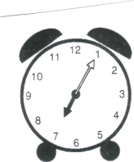
Name________________________ REGROUPING
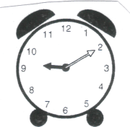

___:____ ____:____ ____:____ ____:____ ____:____ ____:____

____ in. l_____________________l

____ in. l____________________________________l

____ in. l____________________________ l

51  +39 | 54  +15 | 27  +43 | 45  +46 | 63  -27 | 54  -26 | 82  -44 | 73  -27
71  +9 | 30  +9 | 71  +4 | 78  -5 | 25  -8 | 44  -9 | 12  17  +28 | 24  15  +15

- HD HDQ DD P = ____.____
- $ QQ D PP _____._____
- QQQQ D DN P = ____.____
1/4
3/4
2/6
1/3
2/5
3/5
1/5
- _______
- ________
- ______
- 1 tens, 3 hundreds, 0 ones =___________
- twice as much as 4 = _____
- round off to nearest ten:
37 ____, 82____, 67____, 98 ____, 86____, 32 ____,
9. ____
10. ____

Name_____________________________ Date____________37 3-07

Counting by 25:
25 | 50
35  +54 | 27  +38 | 38  +54 | 97  -47 | 42  -28 | 94  -66 | 60  -44 | 74  -56
29  +3 | 47  +4 | 28  +2 | 42  -6 | 53  -5  Put E for even and O for odd | 72  -3 | 22  32  +12 | 16  24  +12

1. $ QDDDD N = $___._____
- $ HDQDD P= $___._____
- HD QQ DNNN = $___._____
- 0tens, 3hundreds, 8ones = _________
- What part is ________
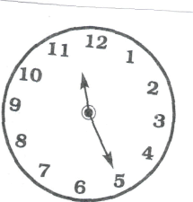
shaded?
- 743___, 845___, 724___
- _____
8. _____
9. How many sides?
_______ ______

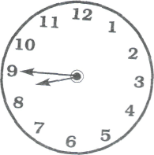
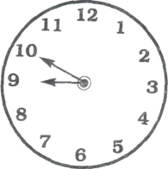

_____:_____ _____:_____ _____:_____ _____:_____ _____:_____

Name_________________ Date________34 3-07

Counting by 10 BACKWARDS:
300 | 290

- $ Q DN P = $___.____
- $ HD Q D = $___._____
- QQQQ D N P = $___._____
- 3:00 30 minutes later ___:___
- 1 dozen is 3 6 9 12 18
- 400+80+1 = ________
- 7 ones 8 tens, 2 hundreds, =__________
8. Twice as much as 6=____
9 Odd or Even: . Put E for even and O for odd
785___, 25___, 88___, 36___, 45___, 34___, 698 ___, 145 __
10. ________________
________________

63  +33 | 48  +44 | 38  +75 | 39  +25 | 63  -59 | 82  -47 | 47  -22 | 80  -56
25  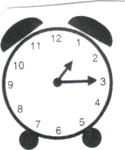  +9 | 78  +7 | 40  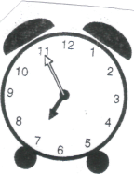  +5 | 72  -7 | 56  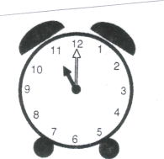  -8 | 35  -8  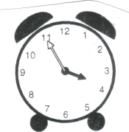 | 13  33  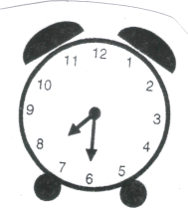  +27 | 15  15  +25

____:____ ____:____ ____:____ ____:____ ____:____ ____:____
Name___________________ Date________ 35 3-07
Counting by 1 BACKWARD:
201 | 200

1. $ Q Q D D P= $___.____
2. Q QQDD N P P = $___.____
7. 318, 344, 367, 312 (in order)
_____ _____ _____ _____

3. Q Q Q DN N = _________¢
4. second _____, sixth _____
Write the numbers correctly.
5. 45 minutes past 3:00 is ____:_____
6. Twice as much as 5 is _____
8. thirty-nine (write the number) ____
9. Even or Odd: Write E or O
457____, 22____, 472____, 184____, 23____, 87 ____

1. _____ in. l_________________________________________l
2. _____ in. l________________________l
3. _____ in. l________________________________l

35  +63 | 47 +47 | 38  +23 | 42  +35 | 85  -59 | 71  -47 | 61  -45 | 50  -22
58  +5 | 52  +8 | 37  +5 | 69  -4 | 47  -9 | 96  -7 | 12  21  +23 | 4  16  +45

