Indian Turquoise Bracelets
You’ll need:
- discarded tubes from toilet paper
- wrapping paper
- pinto beans
- lima beans
- turquoise colored paint
- silver colored paint
- glue
( You may be creative and use other materials for the beans.)

Directions:

Cut tubes into 3 or 4 inch sections. Cut an opening to enable tube to fit over wrist after completion of project. Paint cardboard tube section with silver paint. Paint beans turquoise. After tube and beans are dry, glue beans on tube to create an Indian bracelet.
Parfleshe | 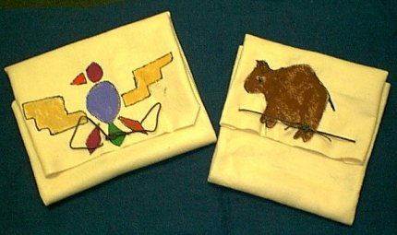

Background Information
A parfleche was used by the Plains Indians to carry their possessions. It was made from a buffalo hide. The hide was cut into a large rectangular shape. Belongings were placed on the center of the hide. Next the hide was folded like and envelope and tied with rawhide straps. The parfleche was made water proof by covering it with a glue made by boiling the tails of beavers.
Materials:
Large brown paper bag.
Markers- brown, black, red,
- Cut a large rectangle from the bag around 18x12.
- Wrinkle it up to look like leather.
- Fold as directed.
- Draw some Native American pictures on it and give yourself a Native American name and sign it.
Fold:
Steps 1 2 3 4 5. Decorate

