Beading |  | 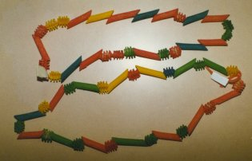
Background Information
Each year Seminole women were given strings of beads on their birthdays. One new string was added each year until the women turned 40 years old. The necklaces covered the women's necks up to their ears and chin. When the women became 40 years old they began to lay one strand of beads aside year by year until only one strand was left. The Seminole women never went into public without the necklaces.
Directions for Making a "Bead" Necklace
- Dye different shaped dry macaroni by placing a small amount of alcohol and food coloring into a plastic bag or jar. Add macaroni and shake the bag until the pasta changes color. Repeat with several different colors. Allow the macaroni to dry overnight before using.
- Thread a large embroidery needle with a piece of yard.
String the colored pasta in an interesting pattern of their choice onto the yarn.
Tie the two ends of the yarn together to form the necklace.

