Bowl Game | 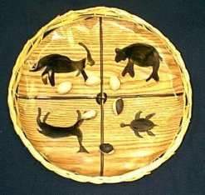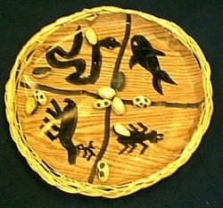
Background Information
The Iroquois Indians played the Sacred Bowl Game during the last day of the "Ceremonial of Midwinter" which marked the end of the year. The wooden bowl was decorated with four clan symbols - the bear, wolf, turtle, and deer. To play the game a player placed the six nuts which were colored on one side inside the bowl and hit the bowl against the ground. If five of the six pits turned up the same color, the player scored and took another turn. The first player to reach 10 points wins the game.
Directions for making the Bowl Game
1. Cut a circle from Contact paper to fit inside a basket paper plate holder. The wood grain Contact paper looks bests.
2. Have students use black markers to decorate the circle.
3. Peel the paper backing from the Contact paper and place the circle into the holder.
4. Gather six flat nuts in the shell or peach pits. Color one side of the nuts with the black marker.

