Drum | 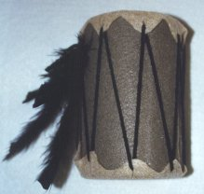
Directions
- Gather the following materials:
  - one empty salt container
  - felt
  - yarn
  - feathers
- Wrap a piece of felt around the salt container. Glue this felt into place.
- Cut two pieces of felt in a waving zig-zagged circle pattern to look like a piece of deer skin. The circles must be approximately 1/2 to 1 inch bigger in diameter than the top of the salt container.Glue one circle to the top and the other to the bottom of the salt container.
- Cut a small hole in each of the longer zig-zags of the circle pieces of felt which have been glued to the top and bottom of the salt container.
- Weave yarn through the holes in the felt going from the top to the bottom of the drum each time.
- Decorate the drum with feathers.

