Iroquois Mask | 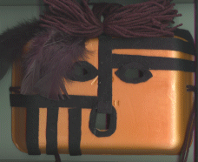
Background Information
An injured or ill Iroquois India would sometimes ask the False Face Society to drive away the spirit of the illness or injury. The False Face Society wore masks carved from wood. After a new member joined the False Face Society he had to make his own mask.
To make the mask the Iroquois walked through the woods until he found a tree whose spirit talked to him. After talking to the tree, the Indian built a fire. He sprinkled tobacco, then stripped bark from the tree. Next the Indian outlined a face and cut out the section to the tree he had outlined. Then the Iroquois went into a secluded shelter to carve the mask. The mask was polished then decorated with hair, feathers, etc.
Make a mask from a Styrofoam meat container, yard, felt, and feathers.

