Medicine Bag  Options below: | 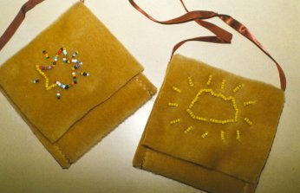
Background Information
Native Americans carried bags of such things as animal and bird skins, pipes, dried herbs, and tobacco. They believed these objects to have special powers. Two of the most important bundles were the pipe bundle and the beaver bundle. The beaver bundle always contained the skin of the beaver along with skins of other animals. Some had feathers of birds, rattles, and other objects. The bundles were used in healing and opened at certain times such as when the first thunder was heard in the spring. The pipe bundle contained tobacco to be used in pipes.
Directions for Making a Medicine Bag
- Cut felt into pieces approximately 8 inches wide by 18 inches tall.
- Fold the bottom edge of the felt up 6 1/2 inches forming a pocket.
- Machine or hand sew the sides together at the 6 1/2 inch fold to form a pocket. Leave the top open.
- Fold the extra material from the top down to form a flap. (The medicine bag is folded similar to an envelop.)
- Sew an 18 to 30 inch piece of ribbon to the top sides of the medicine bag to form a handle.
- You may need to plan a design on paper before sewing it into the top flap portion of the medicine bag with beads.
Options:
- brown paper bag
- Hole puncher to punch holes
- Yarn to sew bag together
- Design with crayons and markers

