How to Make Corn Husk Dolls

Wherever corn was grown as a crop, children, in both Native American and Colonial American families, used husks to fashion dolls. Follow these simple instructions and refer to the accompanying diagrams to create your own unique doll.
Materials Needed:
- string
- scissors
- a bucket of water
- bags of cornhusks- most easily purchased (dried, cleaned and in uniform sizes), at a local craft store
- cornhusk doll diagram page (print out)
Directions:
****Before beginning, soak cornhusks in a bucket of water until they are soft and pliable.****
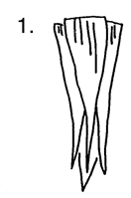 | Take four cornhusks and arrange them in as shown.
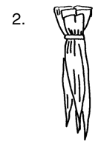 | Using a small piece of string, tie the straight ends together tightly.
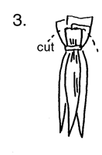 | Trim and round the edges with scissors.
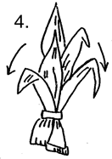 | Turn upside down and pull long ends of husks down over the trimmed edges.
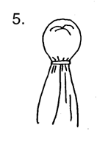 | Tie with string to form the "head."
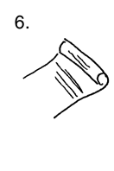 | Take another husk, flatten it, and roll into a tight cylinder.
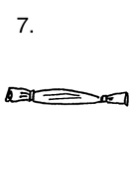 | Tie each end with string. This forms the doll’s arms.
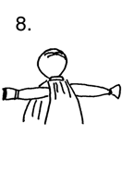 | Fit the arms inside of the long husks, just below the "neck."
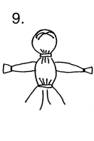 | Tie with string, as shown, to form a "waist."
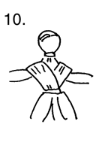 | Drape a husk around the arms and upper body in a criss-cross pattern to form "shoulders."
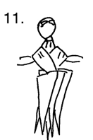 | Take four or five husks, straight edges together, and arrange around waist.  These form a "skirt" for the doll.
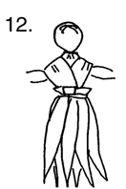 | Tie with string.
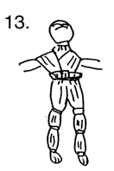 | If desired, follow the diagram to form legs for the doll. Tie legs with small strips of husks as indicated. Finish off the doll by tying small strips of husk around the neck and waist to hide the string. Small scraps of cloth may be used to dress the doll.

Making Native American Pinch Pots

Follow these directions to create a tradition style of earthenware used by Eastern Woodland Native Americans. While clay from streams and rivers would have been used to fashion pottery used for cooking and eating, we recommend using a self-drying clay available at most craft stores. The pots you will create are for educational and decorative purposes only. DO NOT use these pots to hold food or liquids of any kind!
Materials:
- self-drying clay (no firing or baking needed)
- a small container of water for each students
- butcher paper to cover tables
- damp paper towels for each students
- assorted shells, sticks, stones, etc., for etching designs in the pots.
Directions:
1. Take a small handful of clay and shape into a round ball.
2. While holding the ball in the palm of one hand, take the thumb of the other hand and make an indentation in the center of the ball. Keep turning the ball of clay and pressing down with the thumb to within 1/2 inch of the bottom.
3. When the pot is the desired depth, rotate while pinching the sides with the thumb (inside) and fingers (outside).
4. Work from the bottom up until you have achieved the desired shape. As the clay dries it may begin to crack. Keep dipping your fingers in the small container of water and wipe the surface of the pot frequently with damp paper towels.
5. When the pot is finished, used small objects that would normally be found in nature, to etch designs in the pot. Make sure each students etches their initials in the bottom.
6. Allow several days to completely dry. Caution: These pots will break if not treated gently and they are not water resistant.
Pemmican
This traditional Native American food made from dried meat pounded into a paste could be preserved for long periods of time in the form of pressed cakes. It was especially useful on long journeys or hunting expeditions.
- 2 ounces dried beef jerky
- blender or food processor
- rubber spatula
- 4 dried apple slices
- handful of raisins, dried cranberries, or dried cherries
- wax paper
- rolling pin
Grind the dried beef jerky in the blender until it is chopped very finely. Add the dried fruit and raisins. Grind until fine. Empty the mixture from the blender onto a sheet of wax paper. Lay another sheet of wax paper on top and roll over the top sheet with a rolling ping until the pemmican is approximately 1/8 inch thick. Let dry between the wax paper a day or two in the sun. To dry in an over: Flip the pemmican from the wax paper into a pie tin. Set the tin in a 350 degree oven for two hours, turning over several times as it dries.
When completely dry, break of pieces to eat as a snack. Store leftover pemmican in a sealed container or plastic bag in the refrigerator.

Boiled Corn
- 30 cornhusks, green or dried
- 1 or 2 cups of boiling water
- shallow baking pan
- 3-quart pot, 3/4 filled with water
- 1 cup cornmeal
- 1-quart bowl
- mixing spoon
- 1/2 cup honey
- slotted spoon
- scissors
Put the cornhusks in the baking pan and cover with hot water. Bring pot of water to a boil. Pour cornmeal flour into the bowl and mix in 1 cup boiling water. Stir until it reaches the consistency of oatmeal. If too thick, add more boiling water and keep stirring. Stir in the honey. Open one of the wet cornhusks. Drop 2 spoonfuls of the corn mix into the center. Fold the sides of the husk over the corn mix and fold over the ends to form a little packet. Tear off a strip of another husk to use as a string. Tie the husk packet together. Fill other husks to make more packets. Gently drop the packets into the boiling water. Boil for 15 to 20 minutes. Lift them out with a slotted spoon. Cut the husk string, open the packets, and enjoy!

Wild Green Salad
- assortment of wild and cultivated greens
- large bowl
- 1/4 cup vinegar
- 1/3 cup sunflower or peanut oil
- 1 to 2 teaspoons of dill weed, chopped
- 1 tablespoon honey
- small bowl
- fork or wire whisk
- bowls and utensils
Collect the greens (try dandelions and nasturtiums). Rinse the plants in cold water. Tear the plant parts into small pieces and put in a large bowl. Mix all the remaining food ingredients in a small bowl. A fork or wire whisk will blend them well. Pour over greens in the large bowl. Toss and serve.

Indian Turquoise Bracelets
• discarded tubes from toilet paper
• wrapping paper
• pinto beans
• lima beans
• turquoise
• silver colored paint
• glue

Cut tubes into 3 or 4 inch sections. Cut an opening to enable tube to fit over wrist after completion of project. Paint cardboard tube section with silver paint. Paint beans turquoise. After tube and beans are dry, glue beans on tube to create an Indian bracelet.

