Name________________________ Date_______________

Counting by 1’s BACKWARD
251 | 250
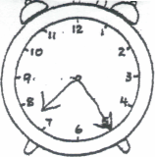
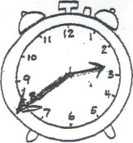
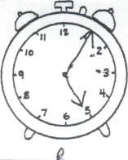
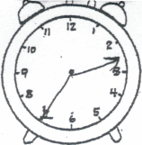
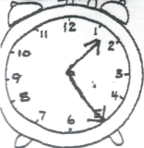
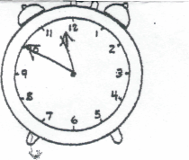

___:___ ___:___ ___:___ ___:___ ___:___ ___:___

28  +27 | 73  -48 | 87  +38 | 25  +63 | 63  -45 | 82  -28 | 44  -14 | 78  -19
40  +14 | 87  -35 | 28  +65 | 45  +72 | 51  -28 | 71  -54 | 94  -87 | 42  -18

- HD Q Q D D P = ___.____
- Q Q D N NN ___________
- 76 63 (< or >)
- 7 + 6 13 (=, + or -)
- 7:20 - 10 minutes later = ___:_____
- twelve minus eight equals _______
- 254 352 (< or >)
1/2 1/3 1/4 1/3 2/4
2/3
- = _____
- (in order) 325 714 572 204
_____ ______ ______ _____
- 8 7 = 17 (=, + or -)

Name________________________ Date_______________

____ in. l___________________________l
____ in. l____________________________________________l
____ in. l______________________________________________________l
____ in. l_________________l

55 45 42 48 74 95 44
+ 28 +26 + 38 + 56 +47 - 35 - 14

4
84 47 81 85 31 30 6
-45 -28 -37 -58 36 24 7
+20 +39_ +4

- $ Q QQ N =$____.____
- HD Q Q D D = $___.____
- 85 83 (< or >)
- 58 66 (< or >)
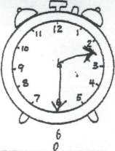
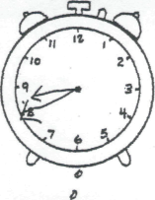
- fourth ______ third _____

- seventeen plus two _______
- 400 +30+7 = __________
- (in order) 766 572 324 125
_____ ______ _____ _____
10. 8 7 = 15 (=, + or -)

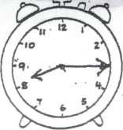
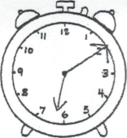
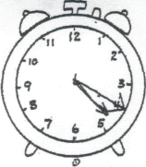
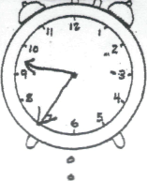

____:_____ ____:_____ ____:_____ ____:_____ ____:_____ ____:_____
Name________________________ Date_______________

Counting by 5’s BACKWARDS
285 | 280

36 24 55 75 38 74 62
+ 29 +56 + 17 + 37 +84 -48 -49

3
65 72 51 84 32 16 2
-29 -55 -16 -36 23 21 8
+17 +21_ +1

- $ Q Q Q N = ____.______
- Q Q Q Q D P _____.________
- $ HD D P P = ___._______
- 1 dozen is 6, 12, 18, 24, 30
- 45 12 (< or >)
- 800 + 50 + 4 = __________
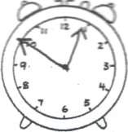
- (in order) 345 325 341 363 _____ ____ ______ _____
- 925 585 (< or >)
- Fourteen plus seven equals _____
10. (How many sides)

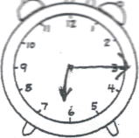
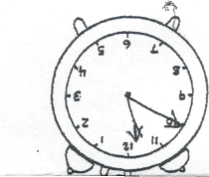
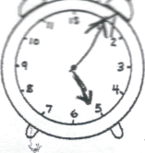
____ ______ ______

____:_____ ____:_____ ____:_____ ____:_____ ____:_____ ____:_____

Counting by 3’s
Name ____________________________ Regrouping add/sub

3 | 6 | 9

52 58 66 85 63 73 62
+ 34 +22 + 12 - 28 -45 -56 -37

45 83 94 82 35 13 7
-27 -68 -26 -35 12 21 3
+10 +22 +2

½ 1/3 ¼
1/5

- $ HD Q N = $___._____
- HD Q Q DPP = $___.______
- 6 8 = 14 (- + = < >)
- 17 8 9 (- + = < >)
- 2 tens 5 hundreds 7 ones = _________
- 8 tens 4 hundreds 6 ones = _________
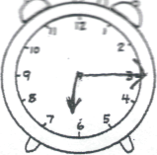
7. ___ shaded
8. (Put in order) 392 354 314 342
_____ _____ ______ _____ 9.1 and half dozen makes 6, 12, 18, 24
10.FIVE hundred and ONE = _____
11.tally 18 ___________________
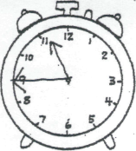
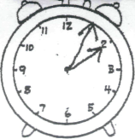

____:_____ ____:_____ ____:_____ ____:_____ ____:_____ ____:_____
By 5’s
Name __________________________________ Regrouping add/sub
485 | 490

30 18 32 43 82 85 66
+ 27 +68 + 52 + 77 - 64 -59 -45

84 65 85 82 12 15 12
-45 -26 -68 -69 22 22 4
+14 +23_ +4

- $ Q Q N P = $____._____
- Q Q Q D D P P P= $ ____.____
- 1 and ½ dozen = ________
- 337 557 (< or >)
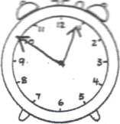
- (in order) 235 450 795 235 ____ ______ _____ _____
____:_____ ____:_____ ____:_____ ____:_____ ____:_____ ____:_____
- 7 4 = 11 (=, + or -)
- 110 - 10 = __________
- ________________
- 15 8 7 (=, + or -)
1/3
3/4
1/5
2/3
1/2

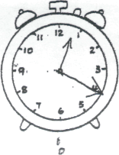
10. ______ shaded

Name________________________ Date_______________

Counting by 2:
366 | 368
Counting by 3’s
3 | 6 | 9

25 37 45 87 91 72
+ 56 +38 + 47 +75 -67 -54

6
92 83 65 83 2 44 5
-35 -34 -27 -56 2 1 26
+4 +23_ +20

- $ Q Q N = ____.______
- HD Q D P P _____ ._____
- HD QQ D P = ___._____
- 2 dozens = ___________
- 78 34 (< or >)

- ______ shaded
- 8 8 = 16 (=, + or -)
- 700 + 30 + 3 = _____
- 2 + 9 5 + 2
10. ODD: 23 73 27 30

Name________________________ Date_______________

Counting by 5:
785 | 790
By 4’s
4 | 8 | 12

87 59 84 45 98 74 65
+ 45 +88 + 43 + 82 -43 -38 - 48

84 61 74 75 21 32 4
-25 -46 -47 -47 26 26 5
+44 +22_ +5

- $ Q Q Q N = ____.____
- HD Q Q P P = ____.____
- 1 dozen = __________
- 5 8 = 13 (=, + or -)
- 4:50 – one hour later = ____:______

- ______ is shaded
- 452 287(< or >)
- 200 + 70 = ___________
- 14 9 = 5 (=, + or -)
10. 8 ones and 3 tens =________

