Name________________ Date________ (regrouping add/sub)

Counting by 1 BACKWARDS
192 | 191

- HD Q N N = __________¢
- Q Q D N P ____________¢
- Q D D N P = _________¢
- Twice as much as 3 is ______
- Twice as much as 5 is _____
- tally 16 ___________________ __________________________
- fifty -three________
- 55 68 < >
- 378 841
- 5 11 6
___ + ___ = ___ ___ - ___ = ___
___ + ___ = ___ ___ - ___ = _

16  +58 | 36  +27 | 58  +18 | 46  +15 | 84  -27 | 65  -36 | 74  -25 | 42  -17
9  +9 | 18  +9 | 63  -44 | 48  +4 | 53  +8 | 74  -8 | 63  -7 | 24  -7
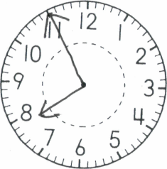
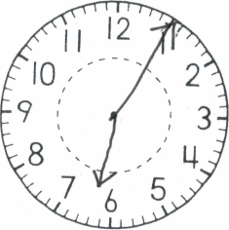
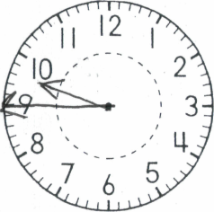
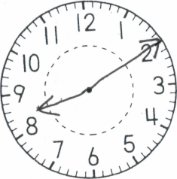
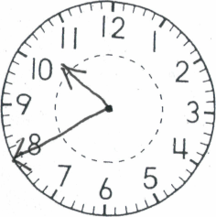

_____:______ ______:______ ______:______ ______:______ ______:______

Name_____________________________Date_________(regrouping add/sub)

___ in. l___________________________________l

___ in. l__________________________________________l

___ in. l______________l

____ in. l__________________________________

- HD QDN N P = ________¢
- Q Q D N N P __________¢
- Q Q Q D N P = _________¢
- How many sides? _________
- How many sides? __________
6. (5 + 7) - 4 = _______
7. two ten, eight ones, 3 hundred ____

- __________________
- 12 8 4
___+___ = ___ __- ___=___
___+___ = ___ __-___ =___

__  36  +57 | __  18  +27 | __  69  +18 | __  47  +15 | __  61  -34 | __  74  -38 | __  91  -24 | __  42  -14
__  68  +9 | __  47  +9 | __  67  +4 | __  71  -4 | _ _  45  -8 | __  60  -8 | __  17  23  +37 | __  34  13  +26

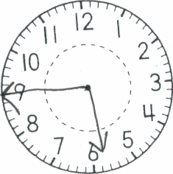
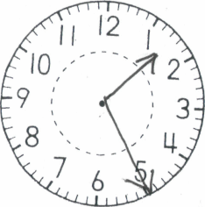
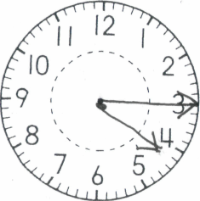
___:____ ___:____ ___:____ ___:____ ___:____ ___:____

Name________________________ Date___________(regrouping add/sub)

Counting by 2:
242 | 244 | 246

____ in. l____________________________________l

____ in. l______________l

____ in. l____________________________ l

36  +48 | 85  +15 | 69  +43 | 47  +14 | 25  +22 | 39  +26 | 96  -44 | 87  -54
44  +9 | 34  +9 | 49  +4 | 83  +8 | 46  +7 | 54  +7 | 27  34  +23 | 44  35  +16

- HD Q DD P = ________¢
- Q Q Q D P __________¢
- Q Q D DN P = ________¢
- _______:________
- _______:________
- _______________
- 7tens, 1 hundreds, 5 ones =___________
- twice as much as 6= _____
- 13 4 9
___+__ = ___ ___-__ = __
__ + __ = ___ __-__=____

Name_____________________________ Date_______________

Counting by 5:
125 | 130
35  +18 | 37  +54 | 18  +24 | 27  +68 | 34  +28 | 25  +66 | 65  -44 | 95  -54
28  +9 | 45  +9 | 27  +4 | 45  +6 | 59  +7 | 78  +7 | 26  24  +23 | 16  23  +47

____ in. l______________l

____ in. l___________________________________l

____ in. l_____________________l

____ in. l____________________________l

Put E for even and O for odd

1. QQ Q N = __________¢
- HD D N P P _________¢
- Q Q D N P = __________¢
- _______:________
- _______:________
- 9 tens, 2 hundreds, 8 ones =________
- Even or Odd 224___, 117___, 743___, 103___, 768___
- Days in the weekend:
1._________________, 2._________________
10. ____________________

Name____________________ Date_________

Counting by 10:
76 | 86

- Q Q NNN P = ______¢
- HD D D N N = _____¢
- Q Q D N P =_______¢
- _____:______
- _____:______
- 800+10+5 = ________
- 4 ones 5 tens, 6 hundreds, =__________
8. Twice as much as 8=____
9 Odd or Even: . Put E for even and O for odd
73___, 12___, 79___, 81___, 62___, 85___, 208 ___, 743 __
10. ________________

58  +33 | 37  +44 | 24  +51 | 57  +35 | 34  +59 | 26  +47 | 85  -51 | 85  -74
48  +3 | 65  +7 | 57  +5 | 25  +7 | 59  +8 | 84  +8 | 12  38  +27 | 26  35  +25

_____ in. l______________________________________l

_____ in. l_______________________________________________l

_____ in. l____________________________l
- _____in. l___________________l
Name______________________ Date________

Counting by 1:
195 | 196

1. Q Q Q D P= _________¢
2. Q Q NNN P P ___________¢
7. 167, 744, 98, 312 (in order)
_____ _____ _____ _____

3. Q Q Q N N= _________¢
4. ______:________
5. ______:________
6. Twice as much as 10 is _____
8. seven hundred and sixty-one _____
9. Even or Odd: Write E or O
22____, 64____, 85____, 71____, 43____, 86 ____

1. _____ in. l________________________l
2. _____ in. l_________________________________________l
3. _____ in. l________________l
4. _____ in. l________________________________l
27  +63 | 25  +45 | 69  +23 | 37  +35 | 26  +52 | 41  +47 | 84  -52 | 74  -31
58  +3 | 52  +7 | 45  +5 | 54  +8 | 55  +8 | 65  +8 | 43  28  +21 | 37  25  +25

