Name___________________________ Date_______(3-07)

Counting by 1 BACKWARDS: (40)
122 | 121

- HD Q Q DD N = $____.____
- $ Q Q D N P = $____.____
- $ Q Q D D N P= $___.____
- third write the number ______
- tenth write the number _______
- Twice as much as 4 is ______
- Twice as much as 9 is _____

- tally 17 _________________
- fifty -three________
- 5+3 3+8 < >
- 2+7 4 + 9
- 5 13 8
___ + ___ = ___ ___ - ___ = ___
___ + ___ = ___ ___ - ___ = __

36  +52 | 26  +27 | 45  +73 | 24  +15 | 62  -27 | 54  -36 | 31  -25 | 45  -17
44  -17 | 52  -29 | 74  -25 | 32  +4 | 71  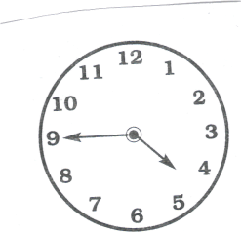  +8 | 44  -8 | 34  -7 | 65  -7
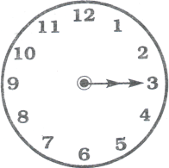
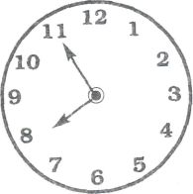
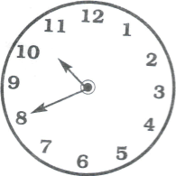
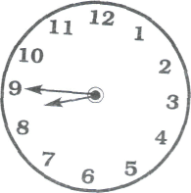
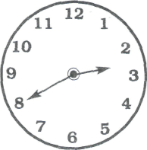
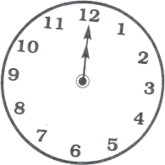

____:____ ____:____ ____:____ ____:____ ____:____ ____:____ ____:____
Name_____________________Date_____________ 3-07 (33)
Counting by 5 BACKWARDS:
25 | 20

___ in. l______l

___ in. l____________________________l

___ in. l___________________________________l

____ in. l__________________________________

8 | 10 | 12

- $ QDNN P= $____.____
- $ QDNP = $_____.____
- Q Q Q D D N P = _______¢
- has ______flat surfaces
__  44  +57 | __  32  +27 | __  78  +18 | __  27  +15 | __  83  -34 | __  52  -38 | __  46  -24 | __  31  -14
__  68  +2 | __  57  +9 | 36  +4 | __  49  -47 | __  65  -28 | __  47  -28 | 17  23  +32 | 31  13  +29
- has ______flat surfaces
6. (5 + 5) - 5 = _______
7. twenty-third write the number _____
8. ______________
__________________
- 17 8 9
___+___ = ___ __- ___=___
___+___ = ___ __-___ =___

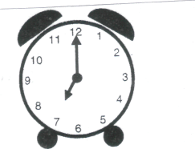
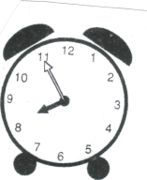
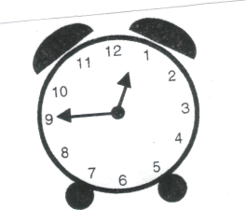
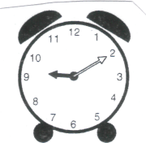
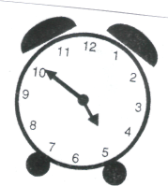
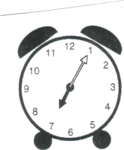
Name________________________ Date_____38 (3-07)

___:____ ____:____ ____:____ ____:____ ____:____ ____:____

____ in. l____________________________l

____ in. l_____________________l

____ in. l____________________________________ l

51  +28 | 37  +15 | 58  +43 | 45  +16 | 76  -27 | 31  -26 | 76  -44 | 64  -27
62  +9 | 37  +9 | 74  +4 | 63  -5 | 84  -8 | 42  -9 | 13  17  +23 | 24  15  +16

- HD Q DD P = ________¢
- Q Q Q D P __________¢
- Q Q D DN P = ________¢
1/2
1/4
2/6
1/3
2/3
3/5

- _______

- ________
- 3 tens, 7 hundreds, 2 ones =___________
- twice as much as 4 = _____
- 11 6 5
___+__ = ___ ___-__ = __
__ + __ = ___ __-__=____

Name_____________________________ Date____________37 3-07

Counting by 25 BACKWARDS:
1000 | 975 | 950
35  +54 | 27  +38 | 38  +54 | 97  -47 | 42  -28 | 94  -66 | 60  -44 | 74  -56
29  +3 | 47  +4 | 28  +2 | 42  -6 | 53  -5  Put E for even and O for odd | 72  -3 | 22  32  +12 | 16  24  +12

1. $ QQ D N = $___._____
- $ HD DD N P= $___._____
- Q Q Q D DN P = $___._____
- 5 tens, 7 hundreds, 0 ones = _________
- What part is ________
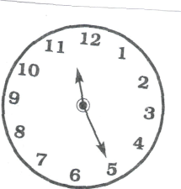
shaded?
- Even or Odd 234___, 278___, 743___, 845___, 724___
- Days in the weekend:
1._________________, 2._________________
10.How many sides? ____ _____
_____:_____ _____:_____ _____:_____ _____:_____ _____:_____

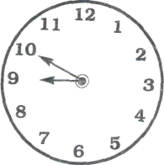

Name_________________ Date________34 3-07

Counting by 10 BACKWARDS:
300 | 290

- $ Q DN P = $___.____
- $ HD Q D = $___._____
- QQQQ D N P = $___._____
- 3:00 30 minutes later ___:___
- 1 dozen is 3 6 9 12 18
- 400+80+1 = ________
- 7 ones 8 tens, 2 hundreds, =__________
8. Twice as much as 6=____
9 Odd or Even: . Put E for even and O for odd
785___, 25___, 88___, 36___, 45___, 34___, 698 ___, 145 __
10. ________________
________________

63  +33 | 48  +44 | 38  +75 | 39  +25 | 63  -59 | 82  -47 | 47  -22 | 80  -56
25  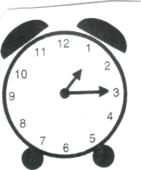  +9 | 78  +7 | 40  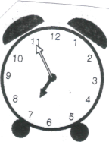  +5 | 72  -7 | 56  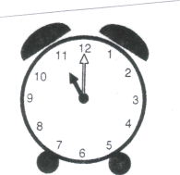  -8 | 35  -8  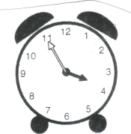 | 13  33  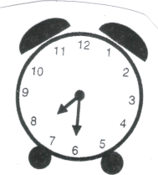  +27 | 15  15  +25

____:____ ____:____ ____:____ ____:____ ____:____ ____:____
Name___________________ Date________ 35 3-07
Counting by 1 BACKWARD:
201 | 200

1. $ Q Q D D P= $___.____
2. Q QQDD N P P = $___.____
7. 318, 344, 367, 312 (in order)
_____ _____ _____ _____

3. Q Q Q DN N = _________¢
4. second _____, sixth _____
Write the numbers correctly.
5. 45 minutes past 3:00 is ____:_____
6. Twice as much as 5 is _____
8. thirty-nine (write the number) ____
9. Even or Odd: Write E or O
457____, 22____, 472____, 184____, 23____, 87 ____

1. _____ in. l_________________________________________l
2. _____ in. l________________________l
3. _____ in. l________________________________l

35  +63 | 47 +47 | 38  +23 | 42  +35 | 85  -59 | 71  -47 | 61  -45 | 50  -22
58  +5 | 52  +8 | 37  +5 | 69  -4 | 47  -9 | 96  -7 | 12  21  +23 | 4  16  +45

