Name___________________________ Date_______(2-07)

Counting by 1 BACKWARDS: (40)
492 | 491

- HD Q Q Q N N = $____.______
- $ Q Q D N P = $____.______
- $ Q D D N P = $_____._____
- third write the number __________________
- tenth write the number _________________
- Twice as much as 4 is ______
- Twice as much as 9 is _____

- tally 14 ___________________
- fifty -three________
- 513 378 < >
- 479 441
- 4 12 8
___ + ___ = ___ ___ - ___ = ___
___ + ___ = ___ ___ - ___ = __

26  +52 | 16  +27 | 58  +73 | 45  +15 | 84  -27 | 74  -36 | 62  -25 | 52  -17
33  -17 | 73  -29 | 52  -25 | 48  +4 | 53  +8 | 12  -8 | 47  -7 | 14  -7
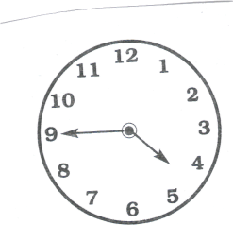
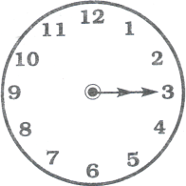
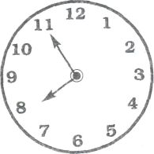
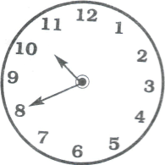
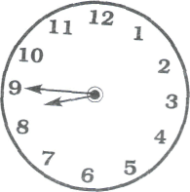
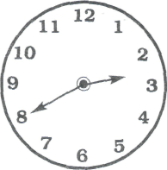
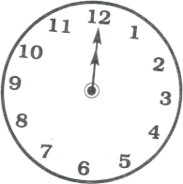

____:____ ____:____ ____:____ ____:____ ____:____ ____:____ ____:____
Name_____________________Date_____________ 2-07 (33)
Counting by 5 BACKWARDS:
125 | 120

___ in. l___________________________________l

___ in. l__________________________________________l

___ in. l______________l

____ in. l__________________________________

8 | 10 | 12

- $ QDN P= $_____.____
- $ QQNP = $_____.____
- Q Q Q D D N P = _______¢
- has ______flat surfaces
__  36  +57 | __  18  +27 | __  69  +18 | __  47  +15 | __  92  -34 | __  65  -38 | __  83  -24 | __  41  -14
__  68  +9 | __  47  +9 | 67  +4 | __  75  -47 | __  85  -28 | __  64  -28 | 14  23  +37 | 34  10  +26
- has ______flat surfaces
6. (9 + 5) - 4 = _______
7. twenty-second write the number ____
8. ______________
__________________
- 15 6 9
___+___ = ___ __- ___=___
___+___ = ___ __-___ =___

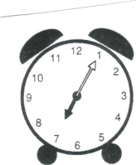
Name________________________ Date_____38 (2-07)
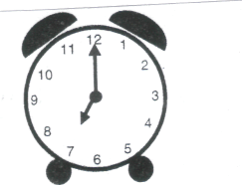
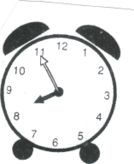
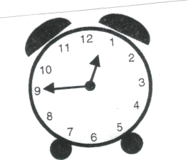
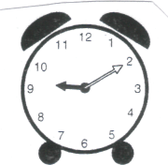
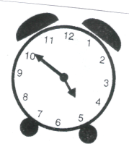

____:____ ____:____ ____:____ ____:____ ____:____ ____:____

____ in. l____________________________________l

____ in. l______________l

____ in. l____________________________ l

46  +48 | 25  +15 | 17  +43 | 42  +14 | 85  -27 | 51  -26 | 96  -44 | 84  -57
74  +9 | 54  +9 | 69  +4 | 88  -5 | 46  -8 | 54  -9 | 13  14  +23 | 24  35  +10

- HD Q DD P = ________¢
- Q Q Q D P __________¢
- Q Q D DN P = ________¢
1/2
1/4
1/5
1/3
2/3
3/5

- _______

- ________
- 4tens, 2hundreds, 5 ones =___________
- twice as much as 4= _____
- 15 6 9
___+__ = ___ ___-__ = __
__ + __ = ___ __-__=____

Name_____________________________ Date_____________32

Counting by 50 BACKWARDS:
1000 | 950
35  +48 | 27  +54 | 38  +24 | 97  -68 | 64  -28 | 82  -66 | 71  -44 | 85  -56
28  +9 | 45  +9 | 27  +4 | 41  -6 | 53  -7  Put E for even and O for odd | 72  -7 | 22  22  +12 | 14  24  +32

1. $ QQ Q N = $___._____
- $ HD D N P= $___._____
- Q Q Q D N P = $___._____
- 9 tens, 2 hundreds, 8 ones = _________
- What part is ________
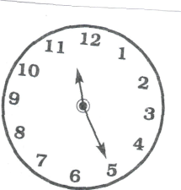
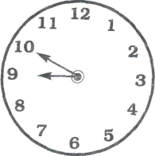
shaded?
- Even or Odd 224___, 117___, 743___, 103___, 768___
- Days in the weekend:
1._________________, 2._________________
10.How many sides? ____ _____
_____:_____ _____:_____ _____:_____ _____:_____ _____:_____

Name_________________ Date_________34

Counting by 10 BACKWARDS:
110

- $ Q NNN P = $___.____
- $ HD D D N = $___._____
- QQQQ D N P = $___._____
- 8:30 30 minutes later ___:___
- 1 dozen is 3 6 9 12 18
- 800+10+5 = ________
- 8 ones 2 tens, 7 hundreds, =__________
8. Twice as much as 7=____
9 Odd or Even: . Put E for even and O for odd
743___, 52___, 39___, 11___, 42___, 45___, 248 ___, 143 __
10. ________________
________________

58  +33 | 37  +44 | 24  +51 | 57  +35 | 84  -59 | 96  -47 | 85  -51 | 85  -37
48  +3 | 65  +7 | 57  +5 | 25  -7 | 52  -8 | 84  -8 | 13  33  +23 | 25  35  +25
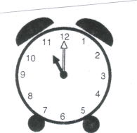
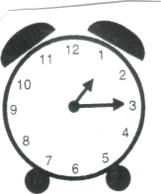
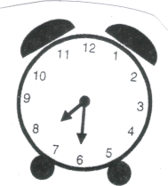
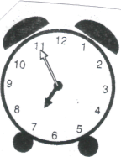
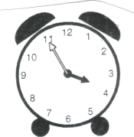

____:____ ____:____ ____:____ ____:____ ____:____ ____:____
Name___________________ Date________ 35
Counting by 1 BACKWARD:
195 | 196

1. $ Q Q Q D P= $___.____
2. Q QQQ NN P P = $___.____
7. 767, 744, 718, 712 (in order)
_____ _____ _____ _____

3. Q Q Q N N = _________¢
4. second _____, tenth _____
Write the numbers correctly.
5. 45 minutes past 6:00 is ____:_____
6. Twice as much as 10 is _____
8. Eighty-nine (write the number) ____
9. Even or Odd: Write E or O
252____, 84____, 145____, 781____, 43____, 96 ____

1. _____ in. l________________________l
2. _____ in. l_________________________________________l
3. _____ in. l________________l

27  +63 | 25 +45 | 69  +23 | 37  +35 | 96  -59 | 65  -47 | 84  -56 | 74  -31
58  +3 | 52  +7 | 45  +5 | 54  -7 | 65  -8 | 83  -8 | 11  21  +21 | 34  15  +25

