Name ____________________________________Math regrouping
Count by 5’s backward
255

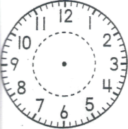
_______:________ ________:________ ________:_______ ________:________ ______:_______

55  +47 | 70  -45 | 63  -34 | 22  +21 | 45  - 6 | 40  -28 | 35  +19
64  -39 | 34  +46 | 73  + 9 | 57  -23 | 54  -36 | 41  + 9 | 65  -42

8  +___  16 | 17  -8 | -8  8 | 15  -___  8 | 16  -9 | 15  -___  9 | 14  -9 | 8  +___  15

- $ Q QN NN =$___._____
- $ QD D P P =$___._____
- Twice as much as 4 is ______
- Twice as much as 9 is _____
- tally 24 _____________________
- has ______flat surfaces
- (5 + 5) - 4 = _______
- . ______________

